SREE NARAYANA COLLEGE, KOLLAM
Semester I, M.Sc. Chemistry/Analytical
PHYSICAL CHEMISTRY
Model Examination –I

Time: 3 hrs. 75 marks

Section A
(Answer any two questions among a), b) and c) from each question. Each carries 2 marks

- (a) Write Euler's theorem
(b) Write combined form of First and Second law
(c) What is the physical significance of free energy
- (a) Identify the symmetry elements present in the following and assign the point group i)
NH3 ii) CO
(b) Prove that S₆² = C₃.
(c) Write a note on abelian group.
- (a) State steady state approximation
(b) Derive the integrated rate expression for an nth order reaction
(c) In the reaction N2 + 3H2= 2NH3, the rate expressed in terms of N2 was found to be
2x10-4 Ms-1. Calculate the rate of consumption of hydrogen
- (a) What is enthalpy of adsorption?
(b) A plot of log x/m against log P was found to be a straight line at an angle 45o with
intercept 0.3010. Calculate the rate of adsorption at a pressure of 3atm.
(c) State the differences between adsorption and absorption
- (a) What are well behaved wavefunctions?
(b) Give the limitations of classical mechanics.
(c) What is an eign function?

Section B
(Answer either a) or b) of each question. Each question carries 5 marks)

- (a) Give the relationship between S, T, V & P
(b) Explain DFT. Give the relationship between G, A, T, V, P
- (a) Explain orthogonality theorem.
(b) Construct the character table for C3v and explain
- (a) Derive the Lindeman mechanism for unimolecular reactions.
(b) Explain the activated complex theory of chemical reactions
- (a) What are the differences between chemisorption and physisorption.
(b) Explain the different types of adsorption curves
- (a) Give de Broglie’s relation and its experimental proof.
(b) Differentiate between Hermitian and Hamiltonian operators.

Section C
(Answer any three questions. Each question carries 10 marks)

- Derive Maxwell's relations and give applications.
- Explain the hybridization in BF3 molecule.
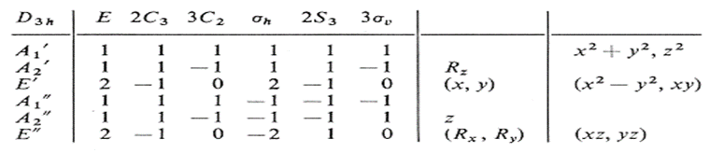

- Explain the collision theory of reactions? What are its limitations?
- a) Derive Langmuir adsorption isotherm
b) What are the different types of physical adsorption isotherms?
- Discuss the postulates of quantum mechanics.

