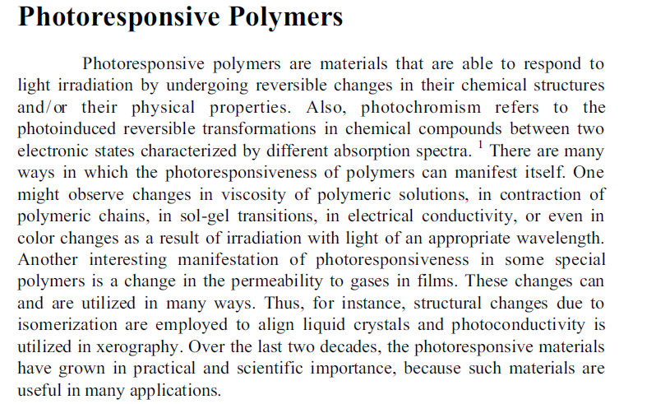
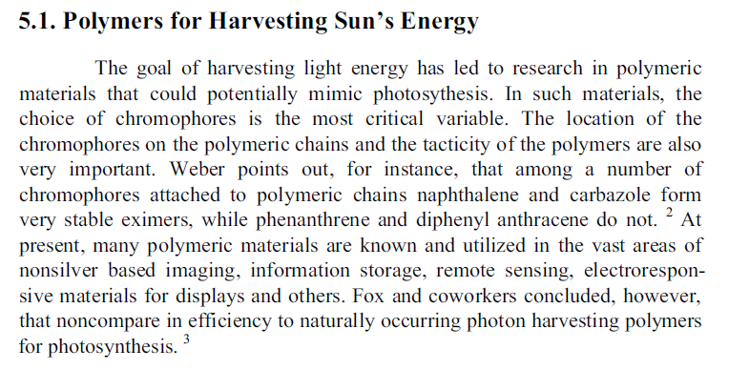

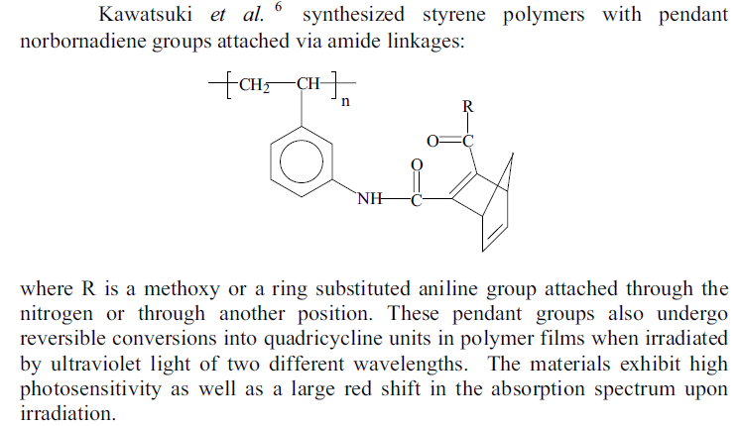
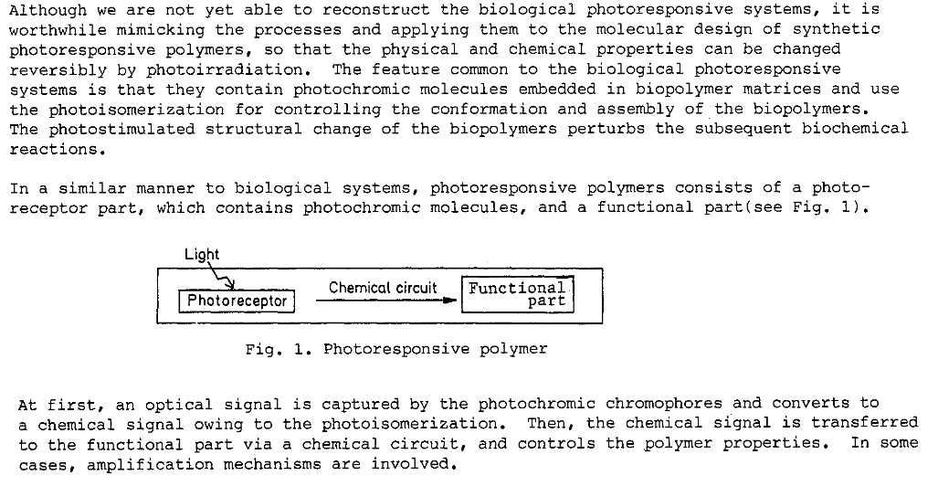
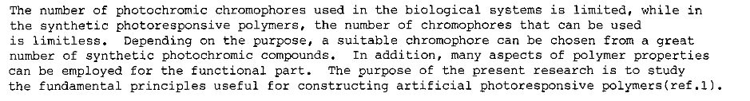

Photorefractive materials are materials that exhibit a temporary change in refractive index when exposed to light. The changing refractive index causes light to change speed throughout the material and produce light and dark regions in the crystal. The buildup can be controlled to produce holographic images for use in biomedical scans and optical computing. The ease with which the chemical composition can be changed in organic materials makes the photorefractive effect more controllable. Photorefractivity is based on the holographic interference phenomena. Photorefractive polymers exhibit large refractive index changes when exposed to low power laser beams. When the optical excitation consists of two interfering coherent beams, the periodic light distribution produces a periodic refractive index modulation. The resulting index change produces a hologram in the volume of the polymer film. The hologram can be reconstructed by diffracting a third laser beam on the periodic index modulation. In contrast to many physical processes that can be used to generate a refractive index change, the photorefractive effect is fully reversible, meaning that the recorded holograms can be erased with a spatially uniform light beam. This reversibility makes photorefractive polymers suitable for real-time holographic applications. The mechanism that leads to the formation of a photorefractive index modulation involves the formation of an internal electric field through the absorption of light, the generation of carriers, their transport and trapping over macroscopic distances. The resulting electric field produces a refractive index change through orientational or non-linear optical effects. Due to the transport process, the index modulation amplitude is phase shifted with respect to the periodic light distribution produced by the interfering optical beams that generate the hologram. This phase shift enables the coherent energy transfer between two beams propagating in a thick photorefractive material. This property, referred to as two-beam coupling, is used to build optical amplifiers. Hence, photorefractive materials are also playing a role in imaging applications. Discovered and studied for several decades mainly in inorganic crystals and semiconductors, the photorefractive effect has not yet found wide spread commercial applications.
Photorefractive polymers are consisted of photocarrier generator, carrier transporter, sensitizer,
nonlinear optical dye, and plasticizer. Each component plays an important role for PR characteristics. Photoconductive polymer works as a photocarrier generator and carrier transporter. Sensitizer is usually used to enhance the photocarrier generation. Free hole carriers induced by photo excitation of sensitizer or photoconductive chromophore through ion pair formation of hole and electron.Generated hole carriers travel through the photoconductive hopping sites and are trapped in dark region. Nonlinear optical dye is responsible for the nonlinear refractive index modulation through Pockels effect. Plasticizer is added to control the glass transition temperature of polymer composite.
Polymers in optical lithography
Photolithography, also termed optical lithography or UV lithography, is a process used in microfabrication to pattern parts of a thin film or the bulk of a substrate. It uses light to transfer a geometric pattern from a photomask to a light-sensitive chemical "photoresist", or simply "resist," on the substrate. A series of chemical treatments then either engraves the exposure pattern into, or enables deposition of a new material in the desired pattern upon the material underneath the photo resist. For example, in complex integrated circuits, a modern CMOS wafer will go through the photolithographic cycle up to 50 times.
Critical issues such as resolution, reliability, speed, and overlay accuracy need to be considered in developing new lithography techniques. Unconventional nanofabrication techniques offer alternatives to photolithography and create opportunities for fabrication on nonplanar surfaces and over large areas. Moreover, they have the potential to below-cost for manufacturing and they are easier to operate and are applicable to biological materials.
In both approaches, polymers play an important role owing to their length scale, their processability, low cost, tunable properties, diverse functionalities and (if block copolymers are used) microphase separation. These features make polymers versatile materials for nanoscale UV
lithography and imprint lithography as examples of existing top-down techniques where these materials are utilized either as a resist layer or as a substrate.
A modern integrated circuit is a complex three-dimensional structure of alternating, patterned layers of conductors, dielectrics, and semiconductor films. This structure is fabricated on an ultrahigh-purity wafer substrate of a semiconducting material such as silicon. the design and selection of polymer materials that are useful as radiation-sensitive resist films. Such polymers must be carefully designed to meet the specific requirements of each lithographic technology and device process. Although these requirements vary according to the radiation source and device process requirements, the following are ubiquitous: sensitivity, contrast, etching resistance, shelf life, and purity. These properties can be achieved by careful manipulation of the polymer structure and molecular properties.
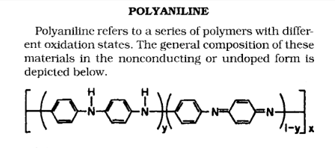
Polymethylmethacrylate (PMMA)

Deposition of PMMA on a substrate
•Multiple spin-coating
•Prefabricated sheet
•Structuring of thick PMMA requires collimated X-ray (0.2 nm -2nm), which are only available in synchrotron facility.
•
Require special mask substrates such as beryllium and titanium; the absorber material can be gold, tungsten, etc.
•
The limited access and costs of a synchrotron facility is a major drawback; although very high aspect ration can be achieved, it has been gradually replaced by other thick PR
such as SU-8.

SU-8 Resist (Microchem)
SU-8 is a negative photores
ist based on EPON SU-8 epoxy resin for the near-UV
wavelengths from
365 nm to 436 nm
. At these wavelengths the photoresist has
very
low optical absorption
, which makes photolithography of thick films with
high aspect
ratios possible.

AZ4562 (Clariant)
•
Positive PR
•
Thickness up to 100 um
•
High resistance to plasma, good adhesion properties, high-resolution capability
•
Typically used as a mold for subsequent
metal electroplating or as master
templates for micromolding. No reports of using AZ4562 directly as structural
material.

