Synthesis of Carbon-Carbon chain polymers by phase-transfer-catalyzed polycondensation

The phase-transfer-catalyzed reactions with quaternary onium salts and crown ethers have attracted increasing interest in the field of both synthetic organic and polymer chemistry. Using this technique it is possible to synthesize various types of condensation polymers which included carbon-carbon chain polymer. For example, phenylacetonitrile was dialkylated with highly reactive halides like methyl and benzyl chloride under phase-transfer catalysis condition for polymer formation and therefore was used in the synthesis of a new type of carbon-carbon chain polymer. Thus the C-C chain polymer is formed by the combination of Phenylacetonitrile, Bis(4-chloromethylphenyl) ether, 1,6-dichlorohexane and trans -1,4-dichloro-2-butene, Quaternary onium salts such as tetraethylammonium chloride (TEAC), tetrabutylammonium chloride (TBAC), benzyltriethylammonium chloride (BTEAC), and cetyltributylphosphonium bromide (CTBPB) and crown ethers such as 18-crown-6 (18-C-6) and dibenzo-24-crown-8 (DB-24-C-8) were used as catalysts.

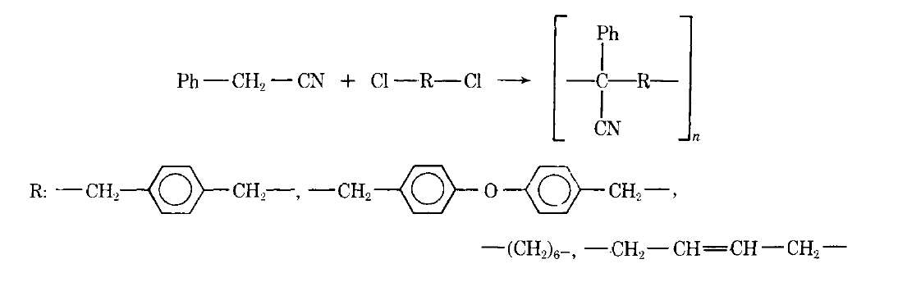

Synthesis of some heterochain polymers in diene elastomers
Polyarylates were prepared by polycondensation of diearboxylic acid dichlorides with dihydric phenols through mechanical treatment of butadione-styreno rubber with reagents in a mixer at high (175 °) and relatively low (50 °) temperatures in the presence of triethylamine, as catalyst.

Polymers may be classified as organic, elemento-organic (or hetero organic) and inorganic. However, it is very difficult to draw sharp boundary between these three classes, because there are many different compounds intermediate between them. Organic polymers include compounds containing, apart from carbon atoms, hydrogen, oxygen, nitrogen, sulphur and halogen atoms; even though the oxygen, nitrogen or sulphur are found to be in the back bone chain. Organic polymers also include polymer substances containing other elements in their molecules provided the atoms of these elements are not in the main chain and are not connected directly to carbon atoms. Elemento-organic or hetero-organic polymers include :(a) Compounds whose chains are composed of carbon atoms and hetero-atoms (except for nitrogen, sulphur and oxygen atoms). (b) Compounds within organic chains if they contain side group chain hetero-atom with carbon atoms connected directly to the chain. (c) Compounds whose main chains consist of carbon atoms and whose side groups contain hetero-atoms connected directly to the carbon atoms of the chain. Inorganic polymers are polymers containing no carbon atoms. Compounds that should be classed as inorganic polymers are those whose chains are composed of different atoms joined by chemical bonds, while weaker ‘intermolecular forces’ act between the chains.
Classified according to composition, industrial polymers are either carbon-chain polymers (also called vinyls) or heterochain polymers (also called noncarbon-chain, or nonvinyls). In carbon-chain polymers, as the name implies, the backbones are composed of linkages between carbon atoms; in heterochain polymers a number of other elements are linked together in the backbones, including oxygen, nitrogen, sulfur, and silicon.
The most common type of thermoplastics, polyolefins are also the some of the most widely used type of plastic. In fact, polyethylene and polypropylene are the most ubiquitous plastics in the world, with variations of each used in a staggering array of products, from soda bottles caps to lab instruments. Polyolefin sheets or foams are used in a wide variety of packaging applications, sometimes in direct contact with food. Polyolefin elastomer POE is used as a main ingredient in the molded flexible foam technology such as in the fabrication of self skinned footwear (for example, Crocs shoes), seat cushions, arm rests, spa pillows, etc. Hydrogenated polyalphaolefin (PAO) is used as a radar coolant. Polyalphaolefin, commonly referred to as a synthetic hydrocarbon, is used in various types of air compressors and turbines including reciprocating, centrifugal, and rotary screw compressors where high pressures and temperatures can be an issue. Polyolefin waste can be converted into many different products, including pure polymers, naphtha, clean fuels, or monomers. Polyethylene in straight chain is used in making plastic carry bags and cloths while the branched versions are known as low-density polyethylene (LDPE) or linear low-density polyethylene (LLDPE); the linear versions are known as high-density polyethylene (HDPE) and ultrahigh molecular weight polyethylene (UHMWPE), with lots of industrial applications like high stabilized pipes and hoses manufacturing. Numerous industrial end uses exist for polypropylene fibre as well, including rope and cordage, disposable nonwoven fabrics for diapers and medical applications, and nonwoven fabrics for ground stabilization and reinforcement in construction and road paving. As a plastic, polypropylene is blow-molded into bottles for foods, shampoos, and other household liquids. It is also injection-molded into many products, such as appliance housings, dishwasher-proof food containers, toys, automobile battery casings, and outdoor furniture. Foamed polystyrene is made into insulation, packaging, and food containers such as beverage cups, egg cartons, and disposable plates and trays. Solid polystyrene products include injection-molded eating utensils, audiocassette holders, and cases for packaging compact discs. More than half of all polystyrene produced is blended with 5 to 10 percent polybutadiene to reduce brittleness and improve impact strength. This blend is marketed as high-impact polystyrene. PVC finds application in the construction trades, where its rigidity and low flammability are useful in pipe, conduit, siding, window frames, and door frames. In combination with plasticizer (sometimes in concentrations as high as 50 percent), it is familiar to consumers as floor tile, garden hose, imitation leather upholstery, and shower curtains.

Li-polymer battery reaction

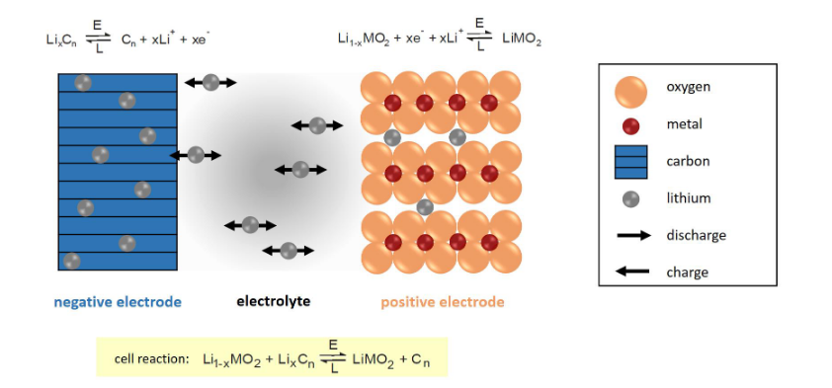

Phase morphology
Polymer mixing is a flexible method to produce materials with special properties, more economical that chemical synthesis. Most polymers are immiscible and their blends show heterogeneous morphologies. The type of morphology and the phase dimensions determine the mechanical and physical properties of the blend at large. The mixing of the components is done mostly in the melt state. The morphology is formed during melt processing and depends on the physical properties of the components, the interfacial tension, the viscosities, the volume fractions and the mixing conditions. The morphology can consist of one phase dispersed in domains in the other phase or of two continuous phases, one inside the other (co-continuous). From all possible morphologies, the latter gives a unique combination of the properties of the components. In the case, e.g., that one phase is conductive, then the continuity of this phase, even if it the minor, results in conductivity of the total.
Polymer Morphology will explore the details of structures commonly encountered in polymeric materials. The approach will involve exploring morphology in terms of levels of structure. Atomic level structure is often governed by thermodynamics and chemistry. The colloidal scale, which dominates polymeric materials, depends on a combination of kinetics and thermodynamics. Macroscopic scale structures generally are dominated by kinetic effects. The relationship between these levels of structure will be used to develop a full picture of the complex morphology of polymeric materials.

