Polymers for Drug Delivery Systems
Polymers have played an integral role in the advancement of drug delivery technology by providing controlled release of therapeutic agents in constant doses over long periods, cyclic dosage, and tunable release of both hydrophilic and hydrophobic drugs. From early beginnings using off-the-shelf materials, the field has grown tremendously, driven in part by the innovations of chemical engineers. Modern advances in drug delivery are now predicated upon the rational design of polymers tailored for specific cargo and engineered to exert distinct biological functions.
Polymeric delivery systems are mainly intended to achieve either a temporal or spatial control of drug delivery. The introduction of the first synthetic polymer-based (polyglycolic acid) DDS led to a heightened interest in the design and synthesis of novel biodegradable polymers that obviated the need to remove the DDS, unlike the non-degradable polymeric systems. A variety of biodegradable polymers have been synthesized to deliver drugs, macromolecules, cells and enzymes. Polyester-based polymers are one of the most widely investigated for drug delivery. Poly(lactic acid) (PLA) poly(glycolic acid) (PGA) and their copolymers poly(lactic acid-co-glycolic acid) (PLGA) are some of the well-defined biomaterials with regard to design and performance for drug-delivery applications. Polyorthoesters have been under development since the 1970s and most research has focused on the synthesis of polymers by addition of polyols to diketene acetals. They are unique among all biodegradable polymers, as mechanical properties can be readily varied by choosing appropriate diols or mixture of diols in their synthesis. Polyaminoacids that have good biocompatibility have been investigated for the delivery of low-molecular-weight compounds. Poly(imino carbonates), which are ‘pseudo’ polyaminoacids, have been synthesized from tyrosine dipeptide to overcome antigenic potentials and poor control of drug release. A relatively new class of biodegradable polymers belonging to polyphosphoesters has a unique backbone consisting of phosphorous atoms attached to either carbon or oxygen. Polyphosphazenes, another new class of polymers are being investigated for delivery of proteins. Chitosans are promising natural polymers that show good absorption-enhancing, controlled release as well as bioadhesive properties. A variety of non-degradable polymers are used in drug delivery of which polysaccharide-based and acrylic-based polymers have found wide application in the fabrication of antibacterial agents, transdermal films and devices. Cyclodextrins are potential high-performance carrier materials that have the ability to alter physical, chemical and biological properties of guest (drug) molecules through the formation of inclusion complexes both in solution and solid state.
Dextrans are being actively investigated for sustained delivery of therapeutic and imaging agents, particularly for injectables and colon-specific DDSs. Polyethylene oxide (PEO) and polyoxypropylene (POP) copolymers are one of the most interesting classes used for nanoparticulate DDSs. Polysiloxanes are a unique class of non-deformable polymer possessing good low-temperature flexibility, excellent electrical properties, water repellency and remarkable biocompatibility, features that are not common with hydrocarbon polymers. Lectins and lectin-like molecules of plant or microbial origin, as well as biotechnologically generated derivatives of such molecules, have interesting characteristics to control the binding, uptake and intracellular routing of macromolecules as well as colloidal carrier systems. Dendrimers belong to a novel and exciting class of highly branched three-dimensional polymer in which growth emanates from a central core molecule such as ammonia, ethylenediamine, polydiamine or benzene tricarboxylic acid chloride. The concept of ‘smart’ polymers originated from the ability of certain synthetic polymers (hydrogels) to mimic the non-linear response of biopolymers (DNA, proteins etc.) caused by cooperative interactions between monomers [25]. Because of their excellent water-absorbing capacity, hydrogels resemble natural living tissues more closely than any other class of synthetic polymeric materials.
Polymer LED
Polymer LED ( light-emitting diode ) - sometimes called light-emitting polymer or polyLED - is a technology based on the use of polymer as the semiconductor material in LEDs. Polymers are chemical substances that consist of large molecules that are, themselves, made from many smaller and simpler molecules: proteins and DNA are examples of naturally occurring polymers; many others, such as nylon, are artificially created. Because of their flexibility and strength, polymers are used for products such as car bumpers and bullet-proof vests.
Because polymers are lightweight and flexible, they can simply and inexpensively be used for the creation of thin film displays for future technologies such as the electronic newspaper . Polymer LEDs have a number of inherent qualities that are ideally suited to such applications: they enable full-spectrum color displays, high brightness at low drive voltages, glare-free viewing, and long operating lifetimes. It is currently possible to create a small text display by structuring the polymer material and electrodes. The technology also offers a great deal of promise as a basis for cheaper, simpler lighting sources.
Polymer LEDs are based on electroluminescence, which converts electric energy into photons. A recent development in the field of PLED is field-induced polymer electroluminescent (FPEL or FIPEL) technology. FIPEL lights are made of three layers of moldable white-emitting polymer that is blended with carbon nanotubes which act as charge injectors, enhancing the material's electroluminescent efficiency. An organic emitting layer made of polymer is sandwiched between a metal cathode and a transparent anode. The polymers that are often used in PLEDs are poly (p-phenylene vinylene) and polyfluorenes.
Similar to the valence and conductive bands in semiconductors, organic layers have highly occupied molecular orbital (HOMO) levels and lowest unoccupied molecular orbital (LUMO) levels. The electrons from cathode are transferred into LUMO and the holes from anode are pushed into HOMO. The recombination of the electron hole pairs results in the emission of photons.
Applications
Some of the typical applications of PLEDs are listed below:
- Flat displays
- Mobile phone screens
- Flexible displays
A lithium polymer battery, is a rechargeable battery of lithium-ion technology using a polymer electrolyte instead of a liquid electrolyte. High conductivity semisolid (gel) polymers form this electrolyte. These batteries provide higher specific energy than other lithium battery types and are used in applications where weight is a critical feature, like tablet computers, cellular telephone handsets and radio-controlled aircraft.
Evolving from Lithium-ion batteries, Lithium polymer batteries offer a distinct advantage over their predecessor in terms of cost, utility, durability and flexibility. A Lithium-polymer battery can be shaped to fit in an array of devices. Another advantage of lithium polymer cells over nickel-cadmium and nickel metal hydride cells is that the rate of self-discharge is much lower.
Liquid Crystalline Polymers
Liquid crystalline polymers (LCP) are a relatively unique class of partially crystalline aromatic polyesters based on 4-hydroxybenzoic acid and related monomers shown in Figure. Liquid crystal polymers are capable of forming regions of highly ordered structure while in the liquid phase. However, the degree of order is somewhat less than that of a regular solid crystal. Typically, LCPs have outstanding mechanical properties at high temperatures, excellent chemical resistance, inherent flame retardancy and good weatherability. Liquid crystal polymers come in a variety of forms from sinterable high temperature to injection moldable compounds. LCPs are exceptionally inert. They resist stress cracking in the presence of most chemicals at elevated temperatures, including aromatic or halogenated hydrocarbons, strong acids, bases, ketones, and other aggressive industrial substances. Hydrolytic stability in boiling water is excellent. Environments that deteriorate these polymers are high-temperature steam, concentrated sulfuric acid, and boiling caustic materials.
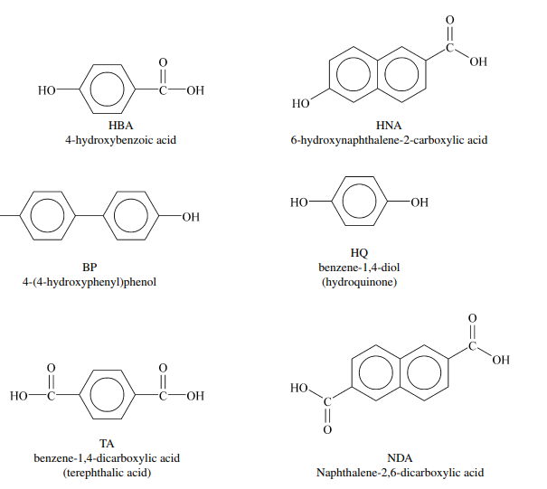
Liquid Crystal Polymers (LCPs) make up a family of thermoplastics which have a unique set of properties. They perform very well in harsh environments, including high heat resistance and tolerance, high electrical resistance, and high chemical resistance. Unlike other polymers such as ABS or nylon, LCPs show a high degree of anisotropy in both solid and liquid crystal phases. This means that the strength, stiffness, and thermal expansion will be greater in one direction, not the same in every direction. The three most commonly used LCPs are PET (Polyethylene terephthalate) copolyester, copolyamide, and polyester-amide, however others are also possible. The reason for anisotropy is the primary bonds within the molecule, causing a high attractive force within the molecule itself. The molecules are bonded together by less attractive secondary bonds, making them more susceptible to separation. When a force is applied transverse to the molecular orientation the secondary bonds receive the majority of the load resulting in easier separation. LCPs are most easily injection molded, although it is possible to use other processing techniques to accommodate the material. The melt temperature of LCPs is between 280- 330ºC, and mold temperatures should be between 70-130ºC. The molecular chains in the melt are highly oriented along the direction of the resin flow.
LCPs demonstrate good cycle repeatability due to their high melt flow and low thermal expansion in the direction of molecular orientation. This allows thin walled parts be easily molded without the part warping. LCPs also show a high resistance to heat, burning, weather and UV rays, and very good electrical insulation properties. LCPs are very resistant to hydrolysis, weak acids and bases, alcohols, aromates, chlorinated hydrocarbons, esters, and keytones throughout a wide range of temperatures. They also display good mechanical properties, with high strength, modulus of elasticity, and toughness.
Liquid crystalline polymers can be classified into main chain, side chain and combined. This classification is based on the place in the polymer where the mesogen (liquid crystal) is inserted, i.e. within the main chain, as side groups, or both within the main chain and as side groups. More complex polymer architectures are also possible. The mesogen used in the construction of the liquid crystalline polymer can be rod-like, disc-like or amphiphilic. In addition to linear polymer structures, cyclic, branched and crosslinked architectures have also been synthesized. Therefore, liquid crystalline polymers display thermotropic and lyotropic mesophases which are similar to those exhibited by thermotropic and lyotropic low molar mass liquid crystals. A characteristic of side chain liquid crystalline polymers is that their polymer backbone adopts a random-coil conformation only in solution and in isotropic melt. In a nematic phase the conformation of the polymer backbone is slightly distorted. Depending on the flexibility of the polymer backbone, its conformation in the smectic phase is so highly distorted that it can even be confined to the smectic layer (in the case of polymers based on very flexible backbones) or it can cross the smectic layer (in the case of rigid backbones).

