Pourbaix diagrams
Pourbaix diagram (Electrode potential / PH diagram) is a graphical presentation of the thermodynamic equilibrium states of a metal-electrolyte system.
Pourbaix diagrams are plotted in the axes Electrode potential of the metal vs. PH of the electrolyte.
Oxidizing conditions are described by the top part of the diagram (high positive electrode potential).
Reducing conditions are described by the bottom part of the diagram (high negative electrode potential).
Acidic solutions are presented in the left side of the diagram (PH lower than 6).
Alkaline solutions are presented in the right side of the diagram (PH higher than 6).
The lines of the diagrams dividing different zones of the equilibrium states are calculated by the Nernst equation:
E = E⁰ - (0.059/n)*lnC_{ion}
Where:
E⁰ - Standard electrode potential, V;
n - number of electrons transferred;
C_{ion} - molar activity (concentration) of ions.
Pourbaix diagrams allow to determine the corrosion behavior of a metal in water solutions i.e. the direction of electro-chemical processes and the equilibrium state of the metal at a certain electrode potential in a water solution at a certain value of PH.
Normally the Poubaix diagrams are built for the water solutions with the concentrations of metal ions 10⁻⁶M and at the temperature 298K (77ºF/25ºC).
In the field of environmental chemistry, the reduction potential is used to determine if oxidizing or reducing conditions are prevalent in water or soil, and to predict the states of different chemical species in the water, such as dissolved metals. pE values in water range from -12 to 25; the levels where the water itself becomes reduced or oxidized, respectively.^{[2]}
The reduction potentials in natural systems often lie comparatively near one of the boundaries of the stability region of water. Aerated surface water, rivers, lakes, oceans, rainwater and acid mine water, usually have oxidizing conditions (positive potentials). In places with limitations in air supply, such as submerged soils, swamps and marine sediments, reducing conditions (negative potentials) are the norm. Intermediate values are rare and usually a temporary condition found in systems moving to higher or lower pE values.^{[2]}
In environmental situations, it is common to have complex non-equilibrium conditions between a large number of species, meaning that it is often not possible to make accurate and precise measurements of the reduction potential. However, it is usually possible to obtain an approximate value and define the conditions as being in the oxidizing or reducing regime.
In the soil there are two main redox constituents: 1) an organic redox systems (mainly ox/red compounds of Fe and Mn) and measurement in water extracts; 2) natural soil samples with all microbial and root components and measurement by direct method.: Practical improvements in soil redox potential (Eh) measurement for characterisation of soil properties. Application for comparison of conventional and conservation agriculture cropping systems.
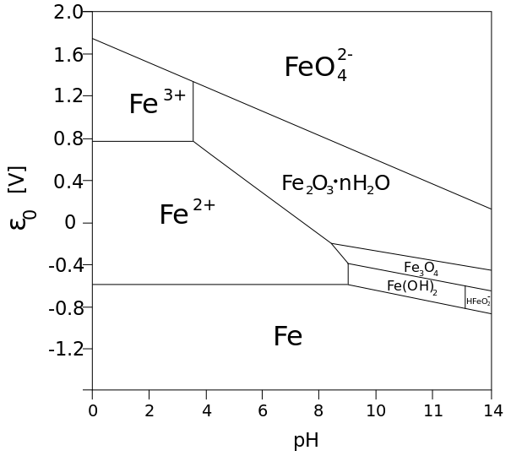
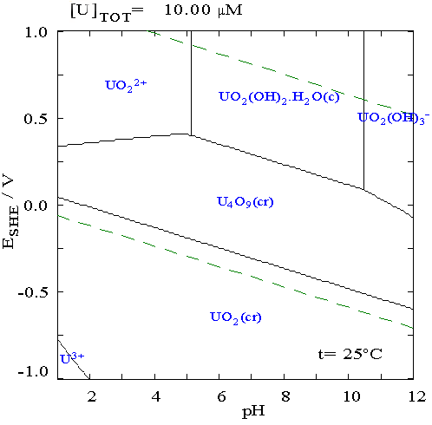

Cation-exchange capacity (CEC) is a measure of how many cations can be retained on soil particle surfaces. Negative charges on the surfaces of soil particles bind positively-charged atoms or molecules (cations), but allow these to exchange with other positively charged particles in the surrounding soil water. This is one of the ways that solid materials in soil alter the chemistry of the soil. CEC affects many aspects of soil chemistry, and is used as a measure of soil fertility, as it indicates the capacity of the soil to retain several nutrients (e.g. K+, NH4+, Ca2+) in plant-available form. It also indicates the capacity to retain pollutant cations (e.g. Pb2+).
- Cation exchange capacity (CEC) is the total capacity of a soil to hold exchangeable cations.
- CEC is an inherent soil characteristic and is difficult to alter significantly.
- It influences the soil’s ability to hold onto essential nutrients and provides a buffer against soil acidification.
- Soils with a higher clay fraction tend to have a higher CEC.
- Organic matter has a very high CEC.
- Sandy soils rely heavily on the high CEC of organic matter for the retention of nutrients in the topsoil.
The clay mineral and organic matter components of soil have negatively charged sites on their surfaces which adsorb and hold positively charged ions (cations) by electrostatic force. This electrical charge is critical to the supply of nutrients to plants because many nutrients exist as cations (e.g. magnesium, potassium and calcium). In general terms, soils with large quantities of negative charge are more fertile because they retain more cations (McKenzie et al. 2004) however, productive crops and pastures can be grown on low CEC soils.
The main ions associated with CEC in soils are the exchangeable cations calcium (Ca2+), magnesium (Mg2+), sodium (Na+) and potassium (K+) (Rayment and Higginson 1992), and are generally referred to as the base cations. In most cases, summing the analysed base cations gives an adequate measure of CEC (‘CEC by bases’). However, as soils become more acidic these cations are replaced by H+, Al3+ and Mn2+, and common methods will produce CEC values much higher than what occurs in the field (McKenzie et al. 2004). This ‘exchange acidity’ needs to be included when summing the base cations and this measurement is referred to as effective CEC (ECEC).
CEC is conventionally expressed in meq/100 g (Rengasamy and Churchman 1999) which is numerically equal to centimoles of charge per kilogram of exchanger (cmol(+)/kg).

