"Blackbody radiation" or "cavity radiation" refers to an object or system which absorbs all radiation incident upon it and re-radiates energy which is characteristic of this radiating system only, not dependent upon the type of radiation which is incident upon it. The radiated energy can be considered to be produced by standing wave or resonant modes of the cavity which is radiating. All objects with a temperature above absolute zero (0 K, -273.15 ºC) emit energy in the form of electromagnetic radiation. A blackbody is a theoretical or model body which absorbs all radiation falling on it, reflecting or transmitting none. It is a hypothetical object which is a “perfect” absorber and a “perfect” emitter of radiation over all wavelengths.
The characteristics of the blackbody radiation are explained with the help of the following laws:
- Wien’s displacement law
- Planck’s law
- Stefan-Boltzmann law
Wien’s displacement law states that the blackbody radiation curve for different temperatures peaks at a wavelength is inversely proportional to the temperature. Using Planck’s law of blackbody radiation, the spectral density of the emission is determined for each wavelength at a particular temperature. The Stefan-Boltzmann law explains the relationship between total energy emitted and the absolute temperature.
Any object with a temperature above absolute zero emits light at all wavelengths. If the object is perfectly black (so it doesn't reflect any light), then the light that comes from it is called blackbody radiation. The energy of blackbody radiation is not shared evenly by all wavelengths of light. The spectrum of blackbody radiation (below) shows that some wavelengths get more energy than others. Three spectra are shown, for three different temperatures. (One of the curves is for the surface temperature of the Sun, 5770 K.).
Some experimental facts about blackbody radiation:
a. The blackbody spectrum depends only on the temperature of the object, and not on what it is made of. An iron horseshoe, a ceramic vase, and a piece of charcoal --- all emit the same blackbody spectrum if their temperatures are the same.
b. As the temperature of an object increases, it emits more blackbody energy at all wavelengths.
c. As the temperature of an object increases, the peak wavelength of the blackbody spectrum becomes shorter (bluer). For example, blue stars are hotter than red stars.
d. The blackbody spectrum always becomes small at the left-hand side (the short wavelength, high frequency side).

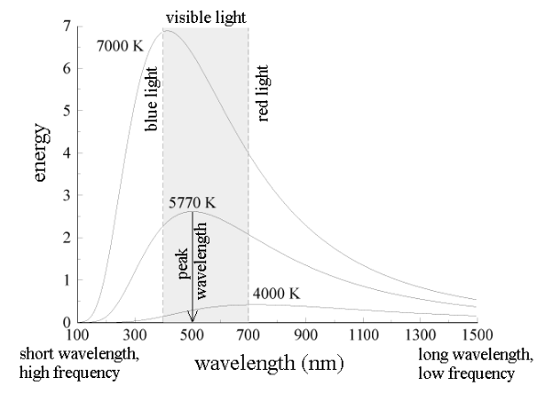

The Photoelectric Effect
When light shines on the surface of a metallic substance, electrons in the metal absorb the energy of the light and they can escape from the metal's surface. This is called the photoelectric effect, and it is used to produce the electric current that runs many solar-powered devices. Using the idea that light is a wave with the energy distributed evenly throughout the wave, classical physicists expected that when using very dim light, it would take some time for enough light energy to build up to eject an electron from a metallic surface. Experiments show that if light of a certain frequency can eject electrons from a metal, it makes no difference how dim the light is. There is never a time delay.
In 1905, Albert Einstein came up with the solution. If Max Planck's idea that energy comes in clumps (quanta) is correct, then light must consist of a stream of clumps of energy. Each clump of light energy is called a photon, said Einstein, and each photon has an energy equal to hf (Planck's constant times the frequency of the light). Therefore the energy of light is not evenly distributed along the wave, but is concentrated in the photons. A dimmer light means fewer photons, but simply turning down the light (without changing its frequency) does not alter the energy of an individual photon. So for a specific frequency light, if a single photon has enough energy to eject an electron from a metallic surface, then electrons will always be ejected immediately after the light is turned on and the photons hit the metal.
The Hydrogen Atom

When a small tube of hydrogen gas is heated, it begins to glow and emit light. Unlike the blackbody radiation that comes from a hot dense solid or gas, this light consists of just a few colors (wavelengths): a red wavelength, a turquoise, and several violets. Classical physicists at the beginning of the century thought they should certainly be able to understand hydrogen, since it is the simplest atom. Hydrogen consists of a positively charged proton at the center, with a negatively charged electron orbiting around it. The electrical attraction between the positive proton and the negative electron keeps the electron in orbit, just like the gravitational attraction between the Sun and the Earth holds the Earth in orbit. There was just one problem. Classical physics said that because the orbiting electron is constantly changing direction, it should emit electromagnetic radiation --- light. As a result, the electron should be continually losing energy. In fact, physicists calculated that the electron should lose all of its energy and spiral down into the proton in only about 0.000000000001 second! In other words, atoms should not exist longer than a mere 10-12 seconds. Niels Bohr provided an explanation in 1913. In the Bohr model of the hydrogen atom, the electron can't orbit the proton in any size orbit it pleases. There are only certain allowed orbits, and each allowed orbit has a certain radius and a certain energy.

Compton effect

The Compton effect states x-rays scattered by loosely bound electrons of target element have reduce energy and frequency. This phenomenon describe scattering between radiation and matter and confirm the particle nature of light. Classical Wave Theory The X-ray are electromagnetic waves generated due to oscillation of electric- field and magnetic-field .When such X-ray waves having frequency “f” fall on target electrons ,the electrons start to oscillate with same frequency “f ”. The oscillating electrons must radiate electromagnetic waves which have again same frequency “f”. It means scattered beam of X-ray and incident beam of X-ray should have same frequency and same wavelength but spectrum of results of Compton Effect shows that scattered beam has intensity peak at two wavelengths. Therefore classical wave theory fails to explain experimental results of Compton effects.
Quantum Mechanics Compton explained his experimental results by postulating that incident X-rays beam is assembly of photons having energy E = h f . These photons make collisions with free electrons in the scattering target .The scattered radiation consist of recoiling photons emerging from the target. The incident photon transfer some of its energy to the free electron during collision so scattered photon must have reduced energy . It means scattered photon has large wavelength than incident photon . This explains the wavelength shift in spectrum of Compton effect.

Planck’s Quantum Theory
Planck postulated that the energy of light is proportional to the frequency, and the constant that relates them is known as Planck’s constant (h). His work led to Albert Einstein determining that light exists in discrete quanta of energy, or photons.
According to Planck’s quantum theory,
- Different atoms and molecules can emit or absorb energy in discrete quantities only. The smallest amount of energy that can be emitted or absorbed in the form of electromagnetic radiation is known as quantum.
- The energy of the radiation absorbed or emitted is directly proportional to the frequency of the radiation.
Meanwhile, the energy of radiation is expressed in terms of frequency as,
E = h ν
Where,
E = Energy of the radiation
h = Planck’s constant (6.626×10^{–34} J.s)
ν= Frequency of radiation
The implication was that frequency is directly proportional to energy, with the higher light frequencies having more energy. This observation led to the discovery of the minimum amount of energy that could be gained or lost by an atom. Max Planck named this minimum amount the “quantum,” plural “quanta,” meaning “how much.” One photon of light carries exactly one quantum of energy. Interestingly, Planck has also concluded that these were only an aspect of the processes of absorption and emission of radiation. They had nothing to do with the physical reality of the radiation itself. Basically, Planck’s work led Einstein in determining that light exists in discrete quanta of energy, or photons.
Planck’s radiation law, a mathematical relationship formulated in 1900 by German physicist Max Planck to explain the spectral-energy distribution of radiation emitted by a blackbody (a hypothetical body that completely absorbs all radiant energy falling upon it, reaches some equilibrium temperature, and then reemits that energy as quickly as it absorbs it). Planck assumed that the sources of radiation are atoms in a state of oscillation and that the vibrational energy of each oscillator may have any of a series of discrete values but never any value between. Planck further assumed that when an oscillator changes from a state of energy E1 to a state of lower energy E2, the discrete amount of energy E1 − E2, or quantum of radiation, is equal to the product of the frequency of the radiation, symbolized by the Greek letter ν and a constant h, now called Planck’s constant, that he determined from blackbody radiation data; i.e., E1 − E2 = hν.
Planck’s law for the energy E_{λ} radiated per unit volume by a cavity of a blackbody in the wavelength interval λ to λ + Δλ (Δλ denotes an increment of wavelength) can be written in terms of Planck’s constant (h), the speed of light (c), the Boltzmann constant (k), and the absolute temperature (T):
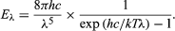
The wavelength of the emitted radiation is inversely proportional to its frequency, or λ = c/ν.
Schrodinger Equation
The Schrodinger equation plays the role of Newton's laws and conservation of energy in classical mechanics - i.e., it predicts the future behavior of a dynamic system. It is a wave equation in terms of the wavefunction which predicts analytically and precisely the probability of events or outcome. The detailed outcome is not strictly determined, but given a large number of events, the Schrodinger equation will predict the distribution of results. The kinetic and potential energies are transformed into the Hamiltonian which acts upon the wavefunction to generate the evolution of the wavefunction in time and space. The Schrodinger equation gives the quantized energies of the system and gives the form of the wavefunction so that other properties may be calculated.
It uses the concept of energy conservation (Kinetic Energy + Potential Energy = Total Energy) to obtain information about the behavior of an electron bound to a nucleus. It does this by allowing an electron's wave function, Ψ, to be calculated.
Solving the Schrödinger equation gives us Ψ and Ψ². With these we get the quantum numbers and the shapes and orientations of orbitals that characterize electrons in an atom or molecule.
The Schrödinger equation gives exact solutions only for nuclei with one electron: H, He⁺, Li²⁺, Be³⁺, B⁴⁺, C⁵⁺, etc. In mathematical language, we say that analytic solutions for Ψ are possible only for one-electron systems.For all other atoms, ions, and molecules, no analytic solutions for Ψ are possible; approximation methods of calculation, such as the orbital approximation and variation theorem, are then utilized.
There is a time-dependent Schrödinger equation and a time-independent Schrödinger equation. The time-independent equation considers the electron's quantum state to be unchanging, hence it considers the electron as a standing wave. The time-independent equation allows electron densities (i.e. the sizes and shapes of atomic and molecular orbitals) to be found using Ψ², the square of the wave function. The wave function itself has no physical meaning. But square of the wave function gives the probability of finding a particle in the given range.
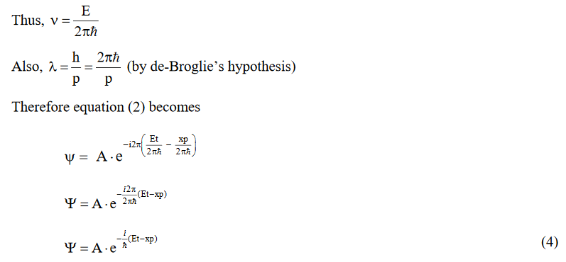
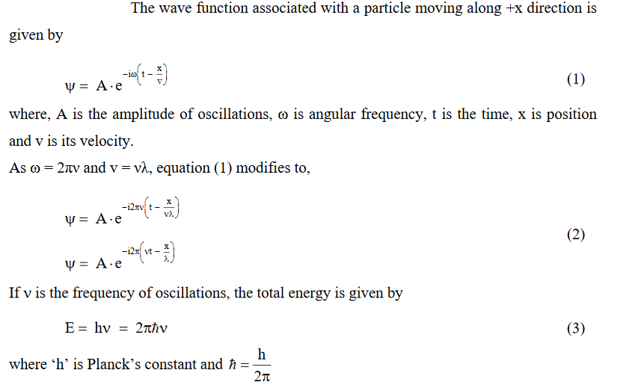
Derivation of SWE
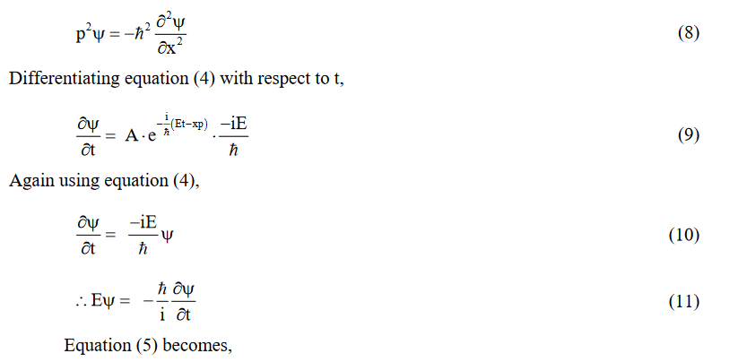
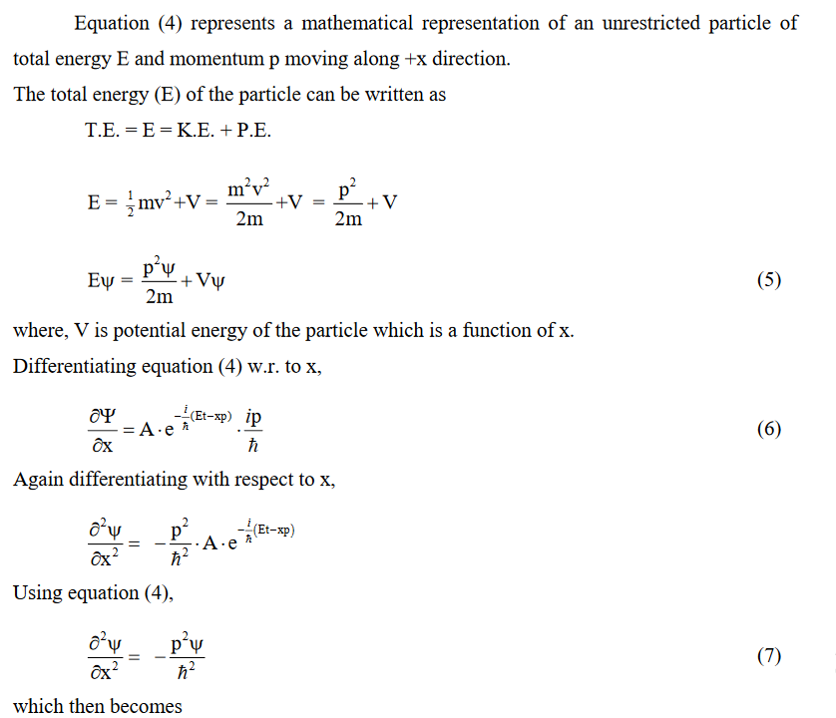
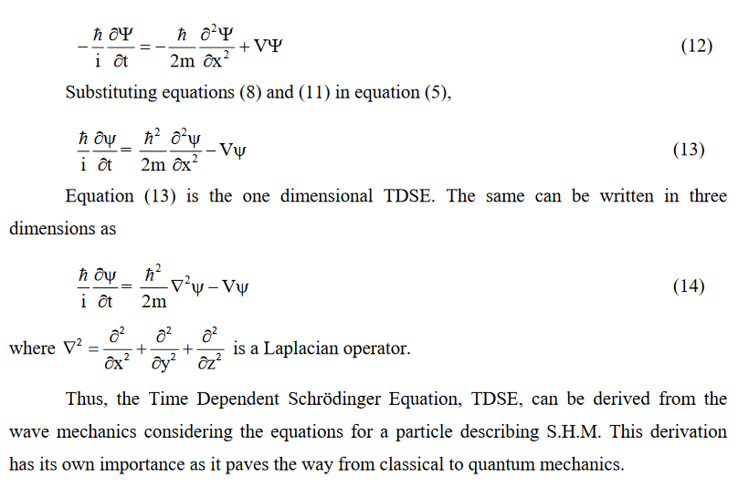
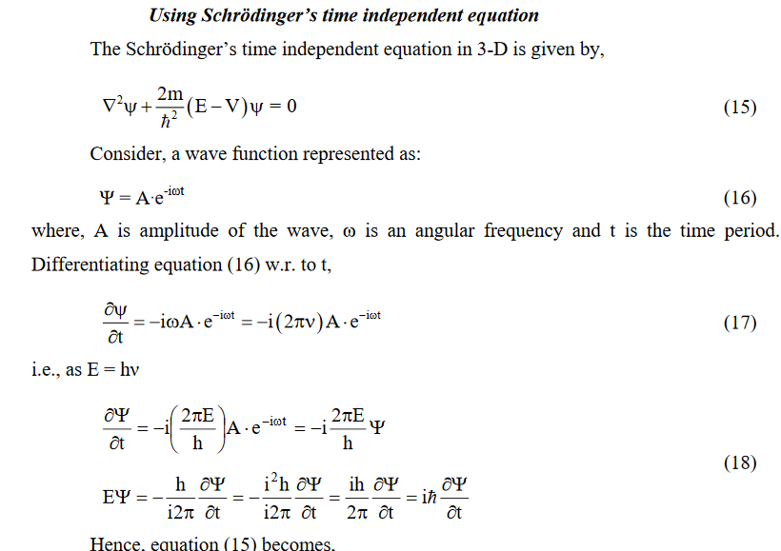
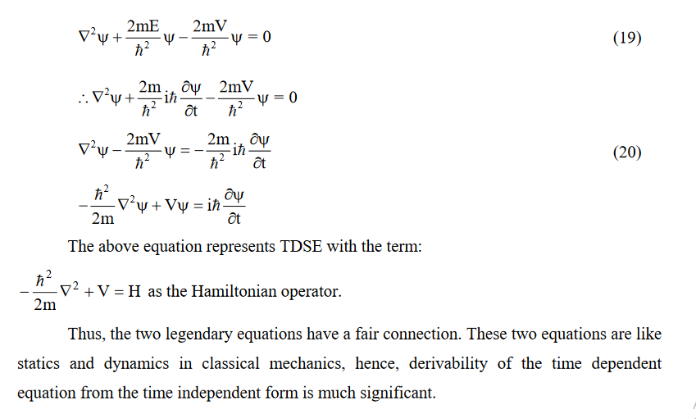

Wave functions and well behaved wave functions
For a physical system consisting of a particle(s) there are associated mathematical functions known as wave functions. A wave function carries ‘information’ about everything that can be known (observable/measurable) about the system. A well behaved (meaningful) wavefunction must be single-valued in r coordinate (because there can be only one probability value at a given position), continuous (so that a second derivative can exist and well behaved) and finite (to be able to normalize the wave function, Ψ integrable). For a function to be normalized the function has to be well behaved.
Postulates of QM
Postulate 1
The properties of a quantum mechanical system are determined by a wavefunction Ψ(r,t) that depends upon the spatial coordinates of the system and time, r and t. For a single particle system, r is the set of coordinates of that particle r=(x₁,y₁,z₁). For more than one particle, r is used to represent the complete set of coordinates r=(x₁,y₁,z₁,x₂,y₂,z₂,…xn,yn,zn). Since the state of a system is defined by its properties, Ψ specifies or identifies the state and sometimes is called the state function rather than the wavefunction.

Postulate 2
The wavefunction is interpreted as probability amplitaude with the absolute square of the wavefunction, Ψ∗(r,t)Ψ(r,t) interpreted at the probability density at time t. A probability density times a volume is a probability, so for one particle
Ψ∗(x1,y1,z1,t)Ψ(x1,y1,z1,t)dx1dy1dz1
is the probability that the particle is in the volume dxdydz located at xl,yl,zl at time t
For a many particle system, we write the volume element as dτ=dx1dy1dz1…dxndyndzn
; and Ψ∗(r,t)Ψ(r,t)dτ is the probability that particle 1 is in the volume dxldyldz1 at xlylzl and particle 2 is in the volume dx2dy2dz2 at x2y2z2, etc.
Because of this probabilistic interpretation, the wavefunction must be normalized.
∫Ψ∗(r,t)ψ(r,t)dτ=1

The integral sign here represents a multi-dimensional integral involving all coordinates: xl…zn. For example, integration in three-dimensional space will be an integration over dV, which can be expanded as:
dV = dxdydz in Cartesian coordinates or
dV = r2sinϕdrdθdϕ in spherical coordinates or
dV = rdrdθdz in cylindrical coordinates.

Postulate 3
For every observable property of a system there is a quantum mechanical operator. The operator for position of a particle in three dimensions is just the set of coordinates x, y, and z, which is written as a vector
R = (x,y,z) = xi⃗ +yj⃗ +zk⃗
The operator for a component of momentum is
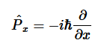
and the operator for kinetic energy in one dimension is
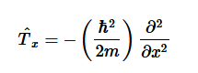

Postulate 4
The time-independent wavefunctions of a time-independent Hamiltonian are found by solving the time-independent Schrödinger equation.
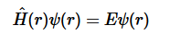
These wavefunctions are called stationary-state functions because the properties of a system in such a state, i.e. a system described by the function Ψ(r), are time independent.

Postulate 5
The time evolution or time dependence of a state is found by solving the time-dependent Schrödinger equation.
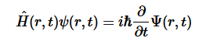

Postulate 6
If a system is described by the eigenfunction Ψ of an operator A^ then the value measured for the observable property corresponding to A^ will always be the eigenvalue a, which can be calculated from the eigenvalue equation.

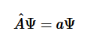

Postulate 7
If a system is described by a wavefunction Ψ, which is not an eigenfunction of an operator A^, then a distribution of measured values will be obtained, and the average value of the observable property is given by the expectation value integral,

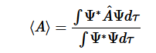
where the integration is over all coordinates involved in the problem. The average value ⟨A⟩, also called the expectation value, is the average of many measurements. If the wavefunction is normalized, then the normalization integral in the denominator of above equation equals 1.
Particle in a 1-Dimensional box
A particle in a 1-dimensional box is a fundamental quantum mechanical approximation describing the translational motion of a single particle confined inside an infinitely deep well from which it cannot escape.
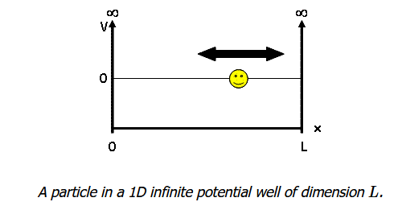
The potential energy is 0 inside the box (V=0 for 0<x<L) and goes to infinity at the walls of the box (V=∞ for x<0 or x>L). We assume the walls have infinite potential energy to ensure that the particle has zero probability of being at the walls or outside the box. Doing so significantly simplifies our later mathematical calculations as we employ these boundary conditions when solving the Schrödinger Equation.
The time-independent Schrödinger equation for a particle of mass m moving in one direction with energy E is
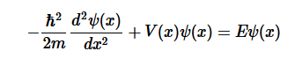
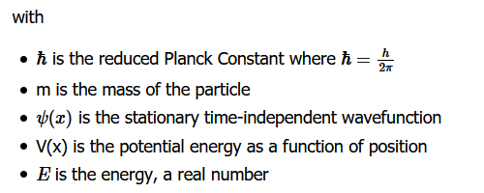
This equation can be modified for a particle of mass m free to move parallel to the x-axis with zero potential energy (V = 0 everywhere) resulting in the quantum mechanical description of free motion in one dimension:
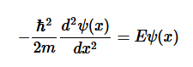
This equation has been well studied and gives a general solution of:
ψ(x)=Asin(kx)+Bcos(kx)
where A, B, and k are constants.
The solution to the Schrödinger equation we found above is the general solution for a 1-dimensional system. We now need to apply our boundary conditions to find the solution to our particular system. According to our boundary conditions, the probability of finding the particle at x=0 or x=L is zero. When x=0, sin(0)=0, and cos(0)=1; therefore, B must equal 0 to fulfill this boundary condition giving:
ψ(x)=Asin(kx)
We can now solve for our constants (A and k) systematically to define the wavefunction.
Solving for k
Differentiate the wavefunction with respect to x:
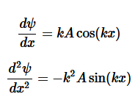

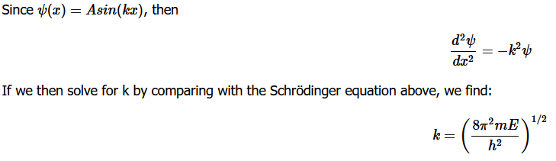
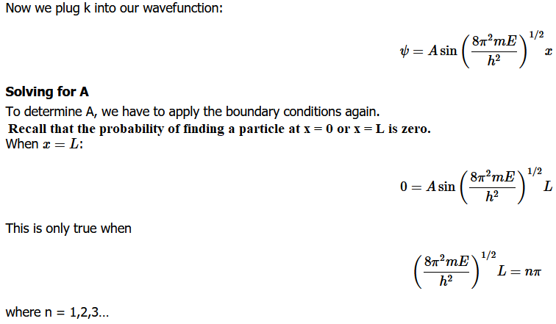
Now
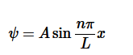

To determine A, recall that the total probability of finding the particle inside the box is 1, meaning there is no probability of it being outside the box. When we find the probability and set it equal to 1, we are normalizing the wavefunction.
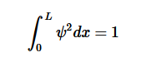
For our system, the normalization looks like:
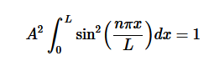
Using the solution for this integral from an integral table, we find our normalization constant, A:
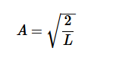
Which results in the normalized wavefunction for a particle in a 1-dimensional box:
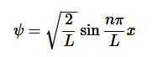

Solving for E results in the allowed energies for a particle in a box:
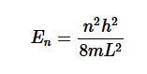
This is an important result that tells us:
- The energy of a particle is quantized and
- The lowest possible energy of a particle is NOT zero. This is called the zero-point energy and means the particle can never be at rest because it always has some kinetic energy.
This is also consistent with the Heisenberg Uncertainty Principle: if the particle had zero energy, we would know where it was in both space and time.

The wavefunction for a particle in a box at the n=1 and n=2 energy levels look like this:
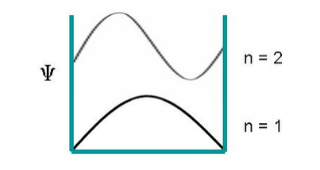
The probability of finding a particle a certain spot in the box is determined by squaring ψ. The probability distribution for a particle in a box at the n=1 and n=2 energy levels looks like this:
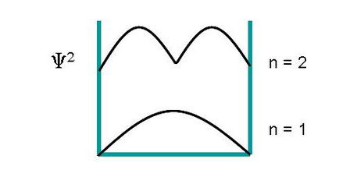
Particle in a 3-Dimensional box
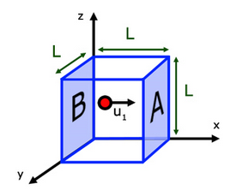
A particle trapped in a 3D box with three lengths Lx, Ly, and Lz. As with the other systems, there is NO FORCE (i.e., no potential) acting on the particles inside the box.

A particle in a 3-D box scheme with equal lengths on all three dimensions
When the potential energy is zero, then the wavefunction obeys the Time-Independent Schrodinger Equation.
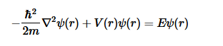
The easiest way in solving this partial differential equation is by having the wavefunction equal to a product of individual function for each independent variable (e.g., the Separation of Variables technique):
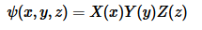
Now each function has its own variable:
- X(x) is a function for variable x only
- Y(y) function of variable y only
- Z(z) function of variable z only
Now substituting the above equation,

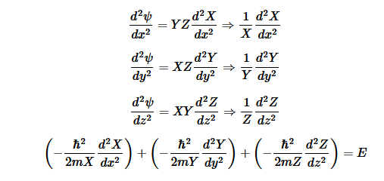
E is an energy constant, and is the sum of x, y, and z. For this to work, each term must equal its own constant. For example,
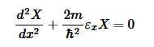
Now separate each term in Equation

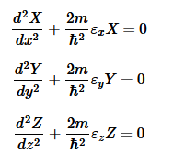
Now we can add all the energies together to get the total energy:
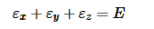

We have now reduced the 3D box into three particle in a 1D box problems.

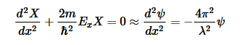
Use the normalization wavefunction equation for each variable:
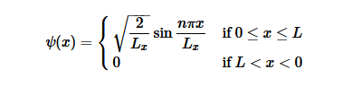
Normalization wavefunction equation for each variable
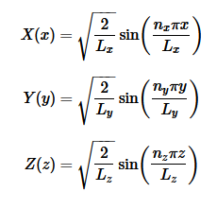
The wavefunctions inside a 3D box is given by
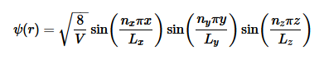

The energy of the particle in a 3-D cube (i.e., a=L, b=L, and c=L) in the ground state which has only one wavefunction and no other state has this specific energy; the ground state and the energy level are said to be non-degenerate. However, in the 3-D cubical box potential the energy of a state depends upon the sum of the squares of the quantum numbers. The particle having a particular value of energy in the excited state may has several different stationary states or wavefunctions. If so, these states and energy eigenvalues are said to be degenerate.

Degeneracy of Hydrogen atom
In quantum mechanics, an energy level is said to be degenerate if it corresponds to two or more different measurable states of a quantum system. Conversely, two or more different states of a quantum mechanical system are said to be degenerate if they give the same value of energy upon measurement. The number of different states corresponding to a particular energy level is known as the degree of degeneracy of the level.
Thus for the degree of degeneracy of Hydrogen atom, we need to calculate how many possible linearly independent energy eigenstates corresponds to energy En of the atom. We knew that for hydrogen atom, its energy eigenstates is given by Ψ_{nlm} where: Principal quantum number n = 1, 2, 3... Azimuthal or Orbital Angular momentum quantum number l = 0, 1, 2,..., n-1 i.e. n choices of them Magnetic Quantum number m = 0, ±1, ±2, ... , ±l i.e. 2l + 1choices of them. Hence for a given n,

Total number of possible energy eigenstates (nlm)=
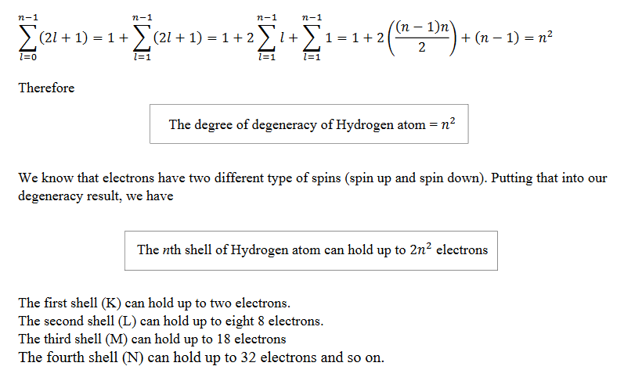

3-D Schrodinger Equation
In three dimensions, the time-independent Schrodinger equation takes the form
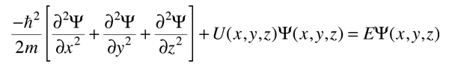
for cartesian coordinates.

The Schrodinger equation can then be written:
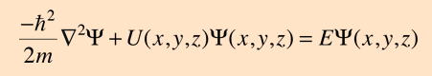

If the potential of the physical system to be examined is spherically symmetric, then the Schrodinger equation in spherical polar coordinates can be used to advantage. For a three-dimensional problem, the Laplacian in spherical polar coordinates is used to express the Schrodinger equation in the condensed form.
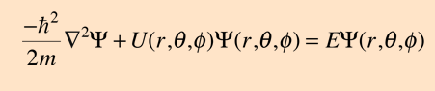
Or in expanded form
